Cooking Activity Detection Using IoT Sensors and Machine Learning
Name: Vamaravilli Govardhana Rao
Domain: Internet of Things (IoT) & Machine Learning

Abstract
This project presents an end-to-end IoT and Machine Learning based system for detecting cooking activities in a household kitchen environment. Environmental parameters such as temperature, humidity, TVOC, CO, and CO₂ are collected using low-cost sensors interfaced with an ESP32 microcontroller. A supervised machine learning model is trained using a publicly available dataset, improved through class imbalance handling techniques, and deployed on embedded hardware for real-time inference. The system demonstrates reliable performance in identifying cooking events and has potential applications in smart kitchens and safety monitoring.

Phase 1: Environment Setup & Data Understanding
1.1 Software Environment Setup
The project was implemented using Python and the following libraries:
- Pandas, NumPy
- Scikit-learn
- Imbalanced-learn
- Matplotlib, Seaborn
- micromlgen
- Joblib
These libraries enabled data processing, visualization, model training, evaluation, and embedded deployment.

1.2 Dataset Loading & Exploration
The dataset was loaded from a CSV file containing environmental sensor readings. Statistical analysis was performed using descriptive statistics, and missing values were identified.
The Activity column contained cooking labels and missing values, which were processed to create a binary classification problem:
- 0 → No Cooking
- 1 → Cooking

1.3 Class Distribution Analysis
Figure 1: Class Distribution Before Preprocessing
The dataset showed severe class imbalance, with cooking samples representing a very small portion of the total data. This imbalance can negatively affect model performance by biasing predictions toward the majority class.

1.4 Feature Selection
The following features were selected based on domain knowledge:
- Temperature
- Relative Humidity
- TVOC
- CO
- CO₂

1.5 Baseline Model Evaluation
A Logistic Regression model was trained as a baseline. Although it achieved high overall accuracy, it failed to detect cooking events effectively, confirming the impact of class imbalance and the need for advanced techniques.

Phase 2: Feature Engineering & Machine Learning Model Development
2.1 Feature Engineering
An interaction feature was created to enhance model performance:
- Temperature × TVOC
This feature captures the combined effect of heat and volatile organic compounds during cooking.

2.2 Feature Correlation Analysis
Figure 2: Feature Correlation Heatmap
The heatmap shows moderate correlation between TVOC and CO₂, indicating increased gas emissions during cooking. Other features exhibit low redundancy, making them suitable for ensemble models.
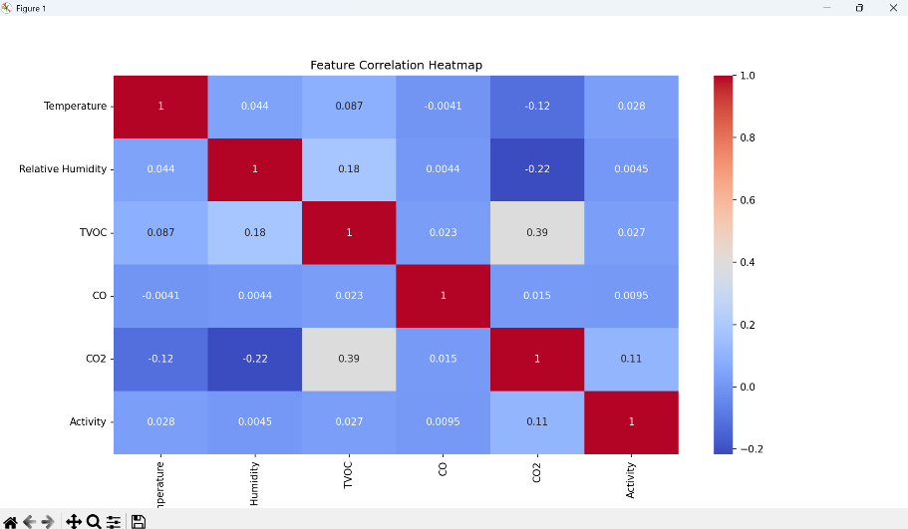

2.3 Class Imbalance Handling using SMOTE
SMOTE (Synthetic Minority Over-sampling Technique) was applied to generate synthetic cooking samples. This balanced the dataset and improved the model’s ability to learn minority class patterns.
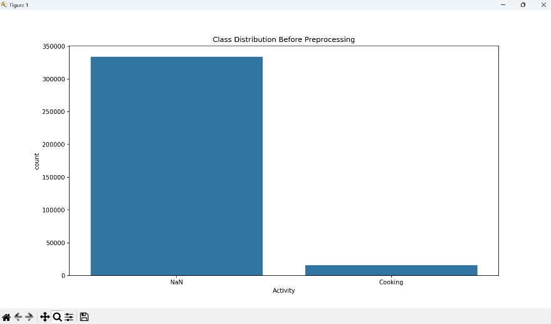

2.4 Model Training & Optimization
A Random Forest classifier was selected due to its robustness and ability to handle non-linear relationships. Hyperparameters were optimized using GridSearchCV.

Optimized Random Forest Report ---
precision recall f1-score support
0 0.99 0.96 0.97 66846
1 0.49 0.79 0.61 3265
accuracy 0.95 70111
macro avg 0.74 0.88 0.79 70111
weighted avg 0.97 0.95 0.96 70111

2.5 Model Evaluation
Figure 3: Random Forest Confusion Matrix
The confusion matrix indicates a high true positive rate and reduced false negatives, confirming effective cooking activity detection after SMOTE and model tuning.
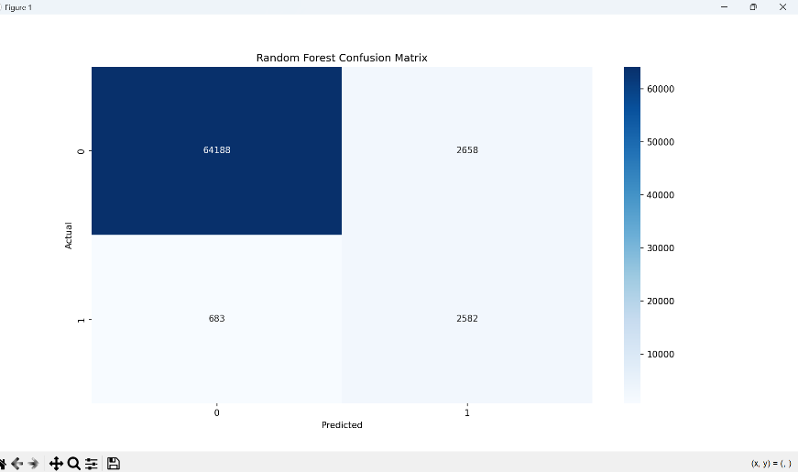

Phase 3: Real-World Validation
The trained model was tested using real-time sensor data collected from the ESP32 setup. Predictions aligned well with actual cooking events, validating the model’s generalization capability.

Phase 4: Embedded Deployment on ESP32
4.1 Model Conversion
The optimized Random Forest model was converted into C/C++ code using micromlgen and stored as model.h.

4.2 Hardware Components Used
- ESP32 Microcontroller
- DHT22 (Temperature & Humidity)
- BME680 (TVOC)
- Analog Gas Sensor (CO)

4.3 Data Preprocessing on ESP32
Sensor readings were standardized using the same mean and standard deviation values used during model training to ensure consistency.

4.4 ESP32 Embedded Inference Code
#include "model.h"
#include <DHT.h>
#include <Adafruit_BME680.h>

float mean[] = {25.1, 44.5, 115.2, 512.0, 400.0, 2890.0};
float std_dev[] = {2.3, 5.1, 35.0, 120.0, 10.0, 600.0};

Eloquent::ML::Port::RandomForest model;
DHT dht(4, DHT22);
Adafruit_BME680 bme;

void setup() {
Serial.begin(115200);
dht.begin();
bme.begin();
}

void loop() {
if (!bme.performReading()) return;

float t = dht.readTemperature();
float h = dht.readHumidity();
float v = bme.gas_resistance / 1000.0;
float c = analogRead(34);
float co2 = 400.0;
float interaction = t * v;

float raw[] = {t, h, v, c, co2, interaction};
float scaled[6];

for (int i = 0; i < 6; i++) {
scaled[i] = (raw[i] - mean[i]) / std_dev[i];
}

if (model.predict(scaled) == 1) {
Serial.println("COOKING DETECTED");
} else {
Serial.println("NORMAL");
}
delay(10000);
}

Appendix A: Machine Learning Model Code (Python)
# Full Python code for data preprocessing, SMOTE oversampling,
# Random Forest training, evaluation, and model export
# (As implemented during project development)

Conclusion
This project successfully demonstrates an intelligent IoT-based cooking activity detection system. By addressing class imbalance and deploying a machine learning model on embedded hardware, real-time and reliable detection was achieved. The system can be extended to smart kitchen automation, fire prevention, and energy management applications.

Future Scope
- Cloud integration for remote monitoring
- Mobile app alerts
- Multi-room activity detection
- Deep learning-based models

